Cairo University Faculty of Computers and Artificial Intelligence
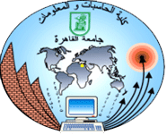


Software Design and Architecture
Software design specification document
2021
Project Team
ID | Name | Email | Mobile
20180054 | Omneya Eid Mohamed | omneyaeid827@gmail.com | 01060846630
20180044 | Islam Ramadan Abdu | islamramadan345543@gmail.com | 01118405750
20180211 | Mahasen Mohamed Ahmed | mahasenmohamed290@gmail.com | 01123658923

Eng. Esraa Abbas

Contents

Class diagram design 2
Sequence diagram design 3
Github repository link 5

Class diagram design

Sequence diagram design

Refactor booking

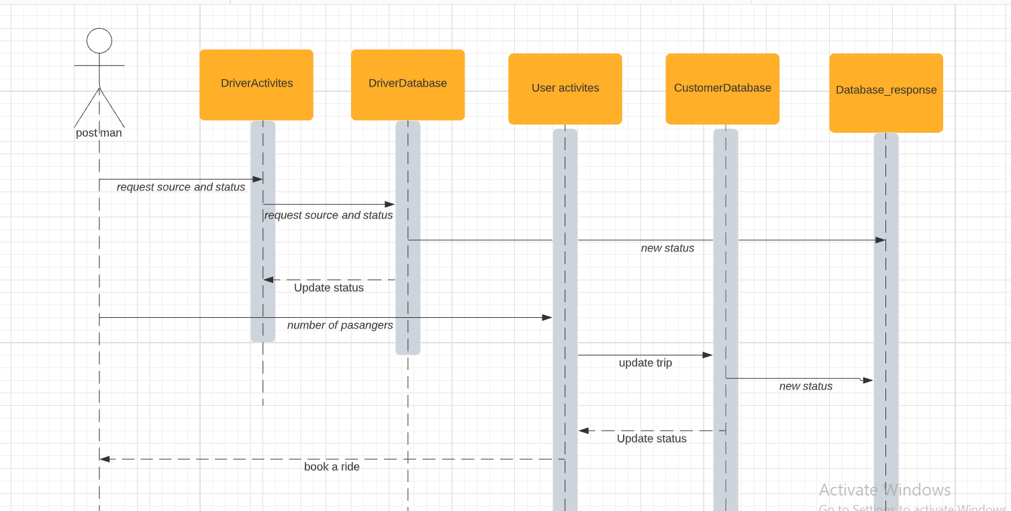

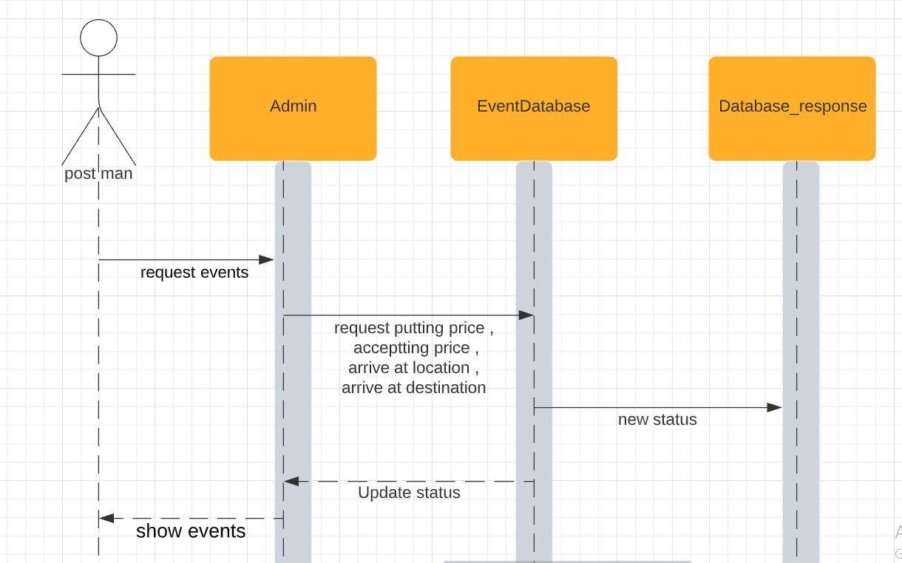
Show the events that happened on specific rides

add discounts on specific areas

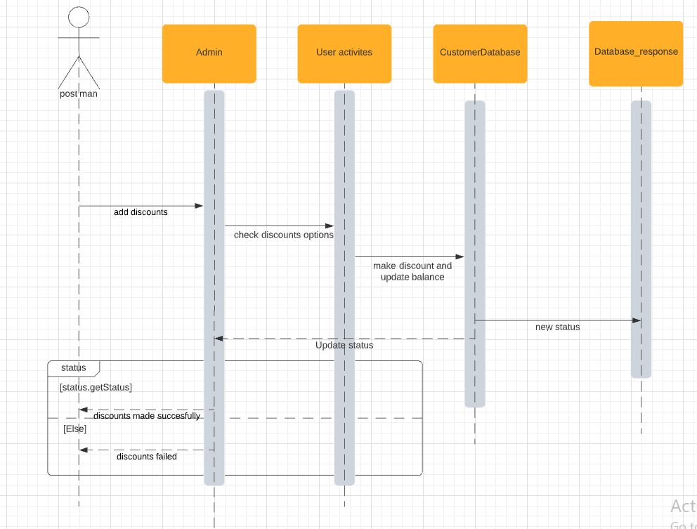

Github repository link
- https://github.com/islamramadanabdo/DriverSW

